### Spring 2025: CS5720 Neural Networks & Deep Learning - ICP-1

### Assignment-1

### NAME: Vanitha Chintalapudi

### STUDENT ID:700756782

Github link : <https://github.com/VanithaChintalapudi10/Neural-network-deep-learning> Video link: <https://drive.google.com/file/d/1ERL73DUzOtSDeQEhXqJhqJWdN9EGAMES/view?usp=drive_link>

1. Write a program that takes two strings from the user: first_name, last_name. Pass these variables to full name function that should return the (full name). o For example: ▪ First_name = “your first name”, last_name = “your last name” ▪ Full_name = “your full name” o Write function named “string_alternative” that returns every other char in the full_name string. Str = “Good evening” Output: Go vnn

Output:

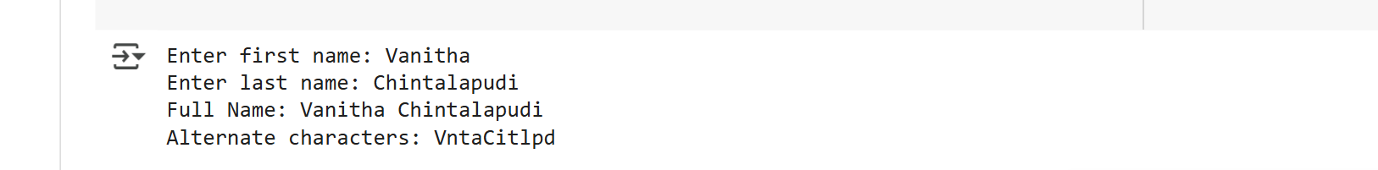

2. Write a python program to find the wordcount in a file (input.txt) for each line and then print the output. o Finally store the output in output.txt file. Example: Input: a file includes two lines: Python Course Deep Learning Course Output: Python Course Deep Learning Course Word_Count: Python: 1 Course: 2 Deep: 1 Learning: 1

* A screenshot of a computer program

  Description automatically generated
* Output:
* 

3. Write a program, which reads heights (inches.) of customersinto a list and convert these heights to centimeters in a separate list using: 1) Nested Interactive loop. 2) List comprehensions Example: L1: [150,155, 145, 148] Output: [68.03, 70.3, 65.77, 67.13]

* A screenshot of a computer

  Description automatically generated

